LOT  89554 | P142036-R6-1-0  14X20X36 R6 PLNM EC/RAW  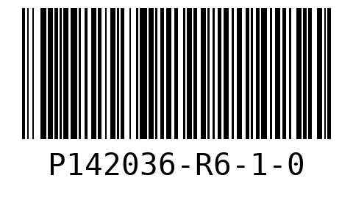  WO 01  LOT 89554  QTY 25
P162036-R6-1-0  16X20X36 R6 PLENUM END CAP/RAW  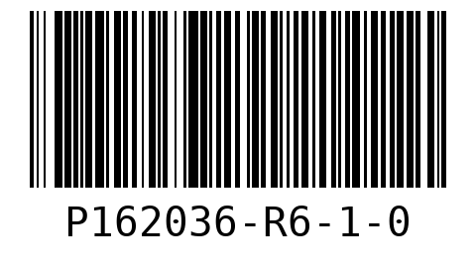  WO 02  LOT 89554  QTY 30 | 30  ffdssdgfsfdsfsfdsd  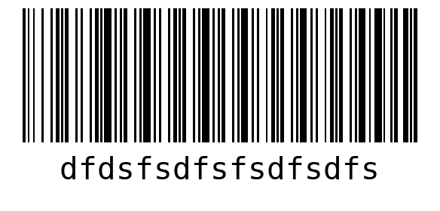  WO fsdfsdfsd  LOT 89554  QTY 20
rerwrewrs
sfdffs
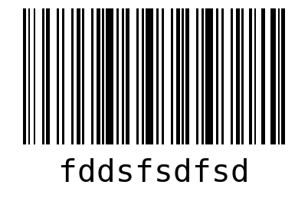
WO fsdfs
LOT 89554
QTY 30

SHEET  1 | P142036-R6-1-0  14X20X36 R6 PLNM EC/RAW  WO 01  LOT 89554
P142036-R6-1-0  14X20X36 R6 PLNM EC/RAW  WO 01  LOT 89554 | P142036-R6-1-0  14X20X36 R6 PLNM EC/RAW  WO 01  LOT 89554
P142036-R6-1-0  14X20X36 R6 PLNM EC/RAW  WO 01  LOT 89554 | P142036-R6-1-0  14X20X36 R6 PLNM EC/RAW  WO 01  LOT 89554

P162036-R6-1-0  16X20X36 R6 PLENUM END CAP/RAW  WO 02  LOT 89554 | P162036-R6-1-0  16X20X36 R6 PLENUM END CAP/RAW  WO 02  LOT 89554
30  ffdssdgfsfdsfsfdsd  WO fsdfsdfsd  LOT 89554 | 30  ffdssdgfsfdsfsfdsd  WO fsdfsdfsd  LOT 89554
30  ffdssdgfsfdsfsfdsd  WO fsdfsdfsd  LOT 89554 | 30  ffdssdgfsfdsfsfdsd  WO fsdfsdfsd  LOT 89554

30  ffdssdgfsfdsfsfdsd  WO fsdfsdfsd  LOT 89554 | 30  ffdssdgfsfdsfsfdsd  WO fsdfsdfsd  LOT 89554
30  ffdssdgfsfdsfsfdsd  WO fsdfsdfsd  LOT 89554 | 30  ffdssdgfsfdsfsfdsd  WO fsdfsdfsd  LOT 89554
rerwrewrs  sfdffs  WO fsdfs  LOT 89554 | rerwrewrs  sfdffs  WO fsdfs  LOT 89554

rerwrewrs  sfdffs  WO fsdfs  LOT 89554 | rerwrewrs  sfdffs  WO fsdfs  LOT 89554
rerwrewrs  sfdffs  WO fsdfs  LOT 89554 | SHEET  2
P142036-R6-1-0  14X20X36 R6 PLNM EC/RAW  WO 01  LOT 89554 | P142036-R6-1-0  14X20X36 R6 PLNM EC/RAW  WO 01  LOT 89554

P142036-R6-1-0  14X20X36 R6 PLNM EC/RAW  WO 01  LOT 89554 | P142036-R6-1-0  14X20X36 R6 PLNM EC/RAW  WO 01  LOT 89554
P162036-R6-1-0  16X20X36 R6 PLENUM END CAP/RAW  WO 02  LOT 89554 | P162036-R6-1-0  16X20X36 R6 PLENUM END CAP/RAW  WO 02  LOT 89554
P162036-R6-1-0  16X20X36 R6 PLENUM END CAP/RAW  WO 02  LOT 89554 | P162036-R6-1-0  16X20X36 R6 PLENUM END CAP/RAW  WO 02  LOT 89554

P162036-R6-1-0  16X20X36 R6 PLENUM END CAP/RAW  WO 02  LOT 89554 | P162036-R6-1-0  16X20X36 R6 PLENUM END CAP/RAW  WO 02  LOT 89554
P162036-R6-1-0  16X20X36 R6 PLENUM END CAP/RAW  WO 02  LOT 89554 | P162036-R6-1-0  16X20X36 R6 PLENUM END CAP/RAW  WO 02  LOT 89554
30  ffdssdgfsfdsfsfdsd  WO fsdfsdfsd  LOT 89554 | 30  ffdssdgfsfdsfsfdsd  WO fsdfsdfsd  LOT 89554

30  ffdssdgfsfdsfsfdsd  WO fsdfsdfsd  LOT 89554 | 30  ffdssdgfsfdsfsfdsd  WO fsdfsdfsd  LOT 89554
30  ffdssdgfsfdsfsfdsd  WO fsdfsdfsd  LOT 89554 | rerwrewrs  sfdffs  WO fsdfs  LOT 89554
rerwrewrs  sfdffs  WO fsdfs  LOT 89554 | rerwrewrs  sfdffs  WO fsdfs  LOT 89554

rerwrewrs  sfdffs  WO fsdfs  LOT 89554 | rerwrewrs  sfdffs  WO fsdfs  LOT 89554
rerwrewrs  sfdffs  WO fsdfs  LOT 89554 | rerwrewrs  sfdffs  WO fsdfs  LOT 89554
rerwrewrs  sfdffs  WO fsdfs  LOT 89554 | SHEET  3

P142036-R6-1-0  14X20X36 R6 PLNM EC/RAW  WO 01  LOT 89554 | P142036-R6-1-0  14X20X36 R6 PLNM EC/RAW  WO 01  LOT 89554
P142036-R6-1-0  14X20X36 R6 PLNM EC/RAW  WO 01  LOT 89554 | P142036-R6-1-0  14X20X36 R6 PLNM EC/RAW  WO 01  LOT 89554
P142036-R6-1-0  14X20X36 R6 PLNM EC/RAW  WO 01  LOT 89554 | P162036-R6-1-0  16X20X36 R6 PLENUM END CAP/RAW  WO 02  LOT 89554

P162036-R6-1-0  16X20X36 R6 PLENUM END CAP/RAW  WO 02  LOT 89554 | P162036-R6-1-0  16X20X36 R6 PLENUM END CAP/RAW  WO 02  LOT 89554
P162036-R6-1-0  16X20X36 R6 PLENUM END CAP/RAW  WO 02  LOT 89554 | P162036-R6-1-0  16X20X36 R6 PLENUM END CAP/RAW  WO 02  LOT 89554
rerwrewrs  sfdffs  WO fsdfs  LOT 89554 | rerwrewrs  sfdffs  WO fsdfs  LOT 89554

rerwrewrs  sfdffs  WO fsdfs  LOT 89554 | rerwrewrs  sfdffs  WO fsdfs  LOT 89554
rerwrewrs  sfdffs  WO fsdfs  LOT 89554 | SHEET  4
P142036-R6-1-0  14X20X36 R6 PLNM EC/RAW  WO 01  LOT 89554 | P142036-R6-1-0  14X20X36 R6 PLNM EC/RAW  WO 01  LOT 89554

P142036-R6-1-0  14X20X36 R6 PLNM EC/RAW  WO 01  LOT 89554 | P142036-R6-1-0  14X20X36 R6 PLNM EC/RAW  WO 01  LOT 89554
P162036-R6-1-0  16X20X36 R6 PLENUM END CAP/RAW  WO 02  LOT 89554 | P162036-R6-1-0  16X20X36 R6 PLENUM END CAP/RAW  WO 02  LOT 89554
P162036-R6-1-0  16X20X36 R6 PLENUM END CAP/RAW  WO 02  LOT 89554 | P162036-R6-1-0  16X20X36 R6 PLENUM END CAP/RAW  WO 02  LOT 89554

P162036-R6-1-0  16X20X36 R6 PLENUM END CAP/RAW  WO 02  LOT 89554 | rerwrewrs  sfdffs  WO fsdfs  LOT 89554
rerwrewrs  sfdffs  WO fsdfs  LOT 89554 | rerwrewrs  sfdffs  WO fsdfs  LOT 89554
rerwrewrs  sfdffs  WO fsdfs  LOT 89554 | rerwrewrs  sfdffs  WO fsdfs  LOT 89554

rerwrewrs  sfdffs  WO fsdfs  LOT 89554 | SHEET  5
P142036-R6-1-0  14X20X36 R6 PLNM EC/RAW  WO 01  LOT 89554 | P142036-R6-1-0  14X20X36 R6 PLNM EC/RAW  WO 01  LOT 89554
P142036-R6-1-0  14X20X36 R6 PLNM EC/RAW  WO 01  LOT 89554 | P142036-R6-1-0  14X20X36 R6 PLNM EC/RAW  WO 01  LOT 89554

P142036-R6-1-0  14X20X36 R6 PLNM EC/RAW  WO 01  LOT 89554 | P162036-R6-1-0  16X20X36 R6 PLENUM END CAP/RAW  WO 02  LOT 89554
P162036-R6-1-0  16X20X36 R6 PLENUM END CAP/RAW  WO 02  LOT 89554 | P162036-R6-1-0  16X20X36 R6 PLENUM END CAP/RAW  WO 02  LOT 89554
P162036-R6-1-0  16X20X36 R6 PLENUM END CAP/RAW  WO 02  LOT 89554 | rerwrewrs  sfdffs  WO fsdfs  LOT 89554

rerwrewrs  sfdffs  WO fsdfs  LOT 89554 | rerwrewrs  sfdffs  WO fsdfs  LOT 89554
rerwrewrs  sfdffs  WO fsdfs  LOT 89554 | rerwrewrs  sfdffs  WO fsdfs  LOT 89554
SHEET  6 | 30  ffdssdgfsfdsfsfdsd  WO fsdfsdfsd  LOT 89554

30  ffdssdgfsfdsfsfdsd  WO fsdfsdfsd  LOT 89554 | 30  ffdssdgfsfdsfsfdsd  WO fsdfsdfsd  LOT 89554
30  ffdssdgfsfdsfsfdsd  WO fsdfsdfsd  LOT 89554 | 30  ffdssdgfsfdsfsfdsd  WO fsdfsdfsd  LOT 89554
SHEET  7 | P162036-R6-1-0  16X20X36 R6 PLENUM END CAP/RAW  WO 02  LOT 89554

P162036-R6-1-0  16X20X36 R6 PLENUM END CAP/RAW  WO 02  LOT 89554 | P162036-R6-1-0  16X20X36 R6 PLENUM END CAP/RAW  WO 02  LOT 89554
P162036-R6-1-0  16X20X36 R6 PLENUM END CAP/RAW  WO 02  LOT 89554 | P162036-R6-1-0  16X20X36 R6 PLENUM END CAP/RAW  WO 02  LOT 89554
P162036-R6-1-0  16X20X36 R6 PLENUM END CAP/RAW  WO 02  LOT 89554 | 30  ffdssdgfsfdsfsfdsd  WO fsdfsdfsd  LOT 89554

30  ffdssdgfsfdsfsfdsd  WO fsdfsdfsd  LOT 89554 | rerwrewrs  sfdffs  WO fsdfs  LOT 89554
SHEET  8 | P142036-R6-1-0  14X20X36 R6 PLNM EC/RAW  WO 01  LOT 89554
P142036-R6-1-0
14X20X36 R6 PLNM EC/RAW
WO 01
LOT 89554

